Error code SY001/SY010

7.The flat table moves 2cm inward. After stopping one second, the carriage moves 5-8cm to right and screen shows SY001.
Reason: The front limit sensor in Y direction is not read.

Check with following steps:
Check the front limit sensor in Y direction is damaged. And sensor connector on sensor board(SY001) is good or replug it.
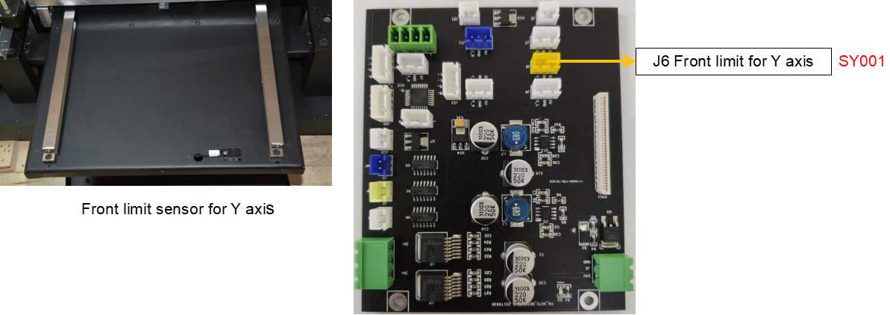

8.The flat table moves 2cm outward. After stopping one second, the carriage moves 5-8cm to right and screen shows SY010.
Reason: The back limit sensor in Y direction is not read.

Check with following steps:
Check the back limit sensor in Y direction is damaged. And sensor connector on sensor board(SY010) is good or replug it.
